LED Zapellin – Chrolis

Pin diagram (DB 25/ 25 pin serial/ parallel port)

Male connector (ribbon cable)

Female connector (Chrolis box 2)

Spectra

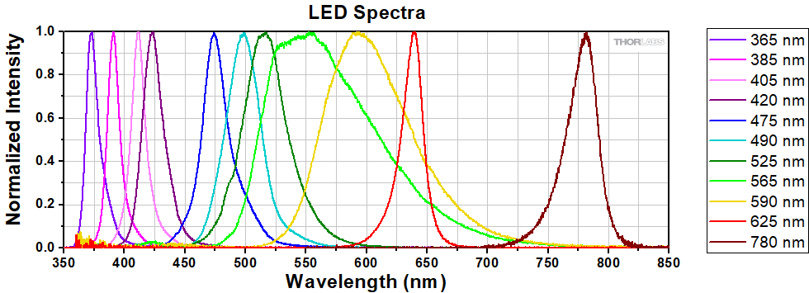

|  |  |  |  |  |  |  |
| --- | --- | --- | --- | --- | --- | --- |
| LED | Chrolis 1 | Filter? | Spectrometer | Chrolis 2 | Filter? | Spectrometer |
| 1 | **365 nm** | ??? | 366.79 | **365 nm** | ??? | 364.64 |
| 2 | 385 nm |  | 384.41 | 420 nm |  | 415.64 |
| 3 | 405 nm |  | 403.45 | 490 nm |  | 491.74 |
| 4 | 475 nm |  | 474.40 | 525 nm |  | 514.34 |
| 5 | 565 nm | **543.5** **nm** ± 10nm laser line | 541.84 | **590 nm** | **610** **nm** ± 10nm bandpass | 604.06 |
| 6 | **590 nm** | **570 nm** ± 10nm bandpass | 568.85 | 625 nm |  | 627.30 |

LED Zapellin instructions: <https://github.com/BadenLab/LED-Zappelin/tree/master/Instruction%20Manual>

Chrolis software instructions: <https://www.thorlabs.com/drawings/bbb56c439d15704a-F1F226D6-BD1E-DD16-0ABA085463BFCCB6/CHROLIS-SoftwareManual.pdf>

|  |  |  |  |  |
| --- | --- | --- | --- | --- |
| LED No. (in microPython script) | Port No. | Setup | Colour | ~Wavelength (nm) |
| 1 | 19 | 2 | Amber | 603 |
| 2 | 21 | 2 | Red | 627 |
| 3 | 14 | 2 | Green | 557? |
| 4 | 27 | 2 | Blue | 489 |
| 5 | 26 | 2 | Violet | 413 |
| 6 | 25 | 2 | UV | 366 |
| 7 | 15 | 1 | Amber | 570 |
| 8 | 2 | 1 | Lime | 535 |
| 9 | 16 | 1 | Blue | 477 |
| 10 | 17 | 1 | UV | 401 |
| 11 | 22 | 1 | UV | 389 |
| 12 | 23 | 1 | UV | 365 |

Rainbow (UV-Red)

6, 12, 11, 10, 5, 9, 4, 3, 8, 7, 1, 2

|  |  |  |  |
| --- | --- | --- | --- |
| LED No. (in microPython script) | Setup | Colour | ~Wavelength (nm) |
| 6 | 2 | UV | 366 |
| 12 | 1 | UV | 365 |
| 11 | 1 | UV | 389 |
| 10 | 1 | UV | 401 |
| 5 | 2 | Violet | 413 |
| 9 | 1 | Blue | 477 |
| 4 | 2 | Blue | 489 |
| 3 | 2 | Green | 557? |
| 8 | 1 | Lime | 535 |
| 7 | 1 | Amber | 570 |
| 1 | 2 | Amber | 603 |
| 2 | 2 | Red | 627 |

What did you do and what did you find?

Chrolis box works with a **3.3V or 5V input**

Using Arduino uno with 1s flash with input in corresponding LED pin (and ground in GND pin)

* To reduce 5V to 3.3V (Ohms law)

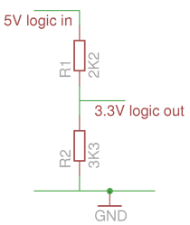

Red + Green – (GND)

LED Zapellin

If ground is put in input pin corresponding to the LED that is on the light turns off on Chrolis.

The potentiometers on LED Zapellin do not effect voltage output only current

* Checked using **multimeter**
* Potentiometer turned all the way down

LED Zapellin doesn’t appear to output pulses

* Checked using **oscilloscope**

Multimeter

* Black hole = black cable
* Red V hole = red cable (if measuring voltage)
* Select DC current upto 20V 
* Attach probes (eg to where LED attaches)
* When LED is on it should measure the voltage, when off should read 0
* (twiddle potentiometer to adjust voltage)
* Can also read current (amps) and resistance (ohms)

Ohms Law: V=IR

Oscilloscope

* To measure voltage/ pulses in voltage

Andre circuit

Voltage signals to chrolis box

Blanking signal

* BNC input
* Blank is inverted
  + When LEDs are on blank is LOW so get signal out

Signal inverter for blanking

End gate (logical end) (x3)

* PWM signal input, if blanking signal inverted => output

2 x 7 outputs (2 x 6 LEDs +Ground)

Combining beams:

Aim:

* to maximise light
* optimise focal point (get light spot in focus)
  + distance of cables from beam splitter from collection cable
    - numbers on rail to remember where they go
  + height of components
    - posts in Thorlabs draws in workshop

Both pointing in at angle?

Both pointing straight towards beam splitter?

Make box to put in and contain the stray light

* rails
* black cardboard next to fridge slots into rails

Secondary holder to prevent movement?

Could have lens to collect light?

Find best compromise

* focal point will differ depending on wavelength
* find a configuration where most of every wavelength gets through

Beamsplitter

https://www.jlab.org/accel/inj_group/laserparts/DichroicTutorial.pdf

<https://www.jlab.org/accel/inj_group/laserparts/Beam_combining_tutorial.pdf>

BSW25 <https://www.thorlabs.com/newgrouppage9.cfm?objectgroup_id=5111>

* coating for 350-1100nm range (fine)
* 50:50
* 45 degree angle of incidence

ToDo

Chrolis

* How to use beam combiner (beam splitter?) to combine LEDs from both boxes
* Check spectra using spectrometer
  + And compare brightness (need to all be the same)
* Sort out power of LEDs (some are brighter than others)
  + Some can be done in code
    - PWM (pulse width modulation)
  + Will need neutrodensity filters
* Combining beams
  + Clean beam splitter
  + Experiment and find best configuration
  + Box
  + Dichroic mirrors??

Circuit

* Talk to Andre

Maybe

* Try another arduino
  + Any Arduino with >13 pins (12 + 1 for blanking signal) eg uno
  + But would have to re-write code
  + Nano
    - Measure pins using oscilloscope to look for pulse
    - Maybe wouldn’t have to mess with code too much

Questions for Andre:

* End of Arduino code: warning: case label value exceeds maximum value for type case '12'